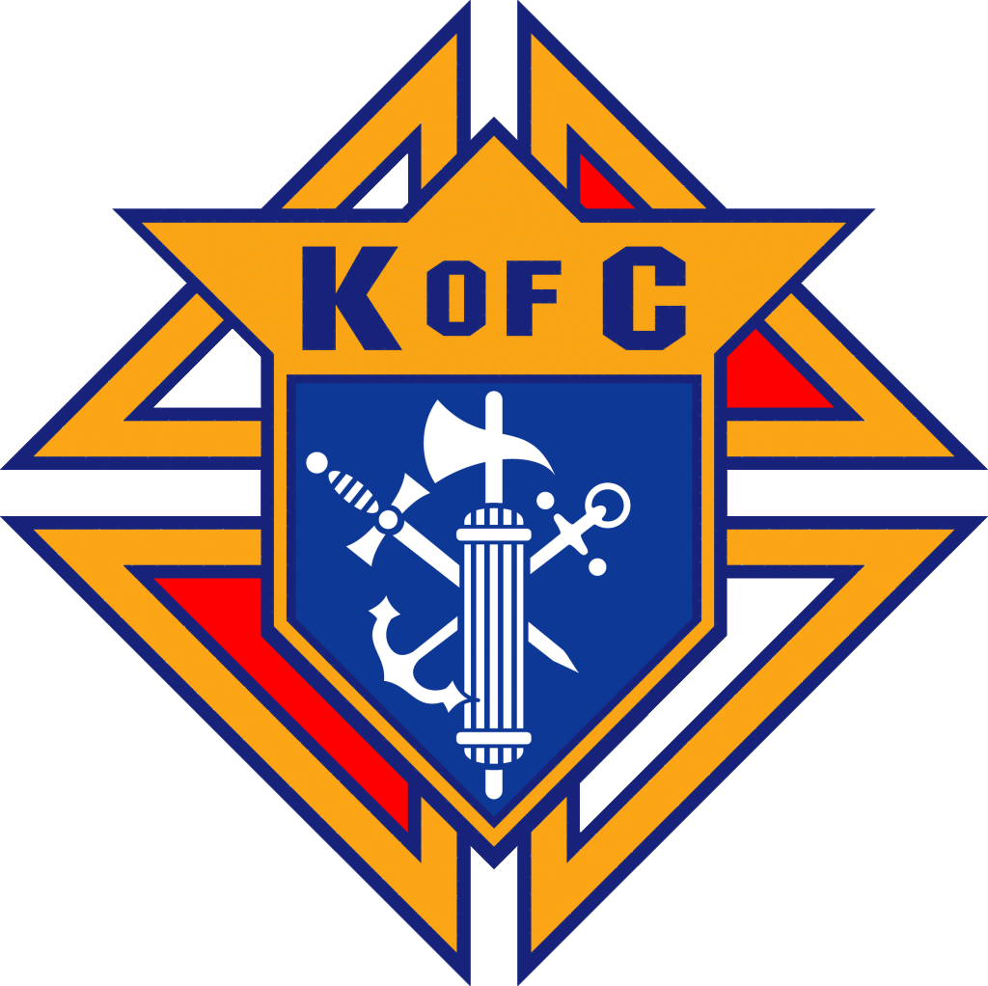
MONTHLY MEETING MINUTES
Knights of Columbus Council # 17304

Date / Time: June 8, 2026
Location: St. Martin de Porres Church - Parish Hall

Grand Knight Nathan Bernard called the meeting to order at 7:00 PM

Opening Prayer
Pledge of Allegiance

Approval of minutes for previous meeting:
- Minutes were posted online.
- Jerry Barta motioned to approve; Rob Deleo seconded.
  - Vote was taken and passed without any corrections.

Grand Knights Report – GK Nathan Bernard:
- 30/60/90 Tracker Reviewed
  - June: Sacred Heart Event - June 10; Officer Installation at St. Catherine’s - June 27; Donut Sunday – June 28
  - July: July 4th Event; Holy Hour – July 16; Donut Sunday – July 26
- Last Meeting of Fraternal Year
  - Budget / Officers & Program Director Discussions Upcoming
- Discussion of programs for Next Program Year

Treasurer’s Report – Sergio Guerrero:

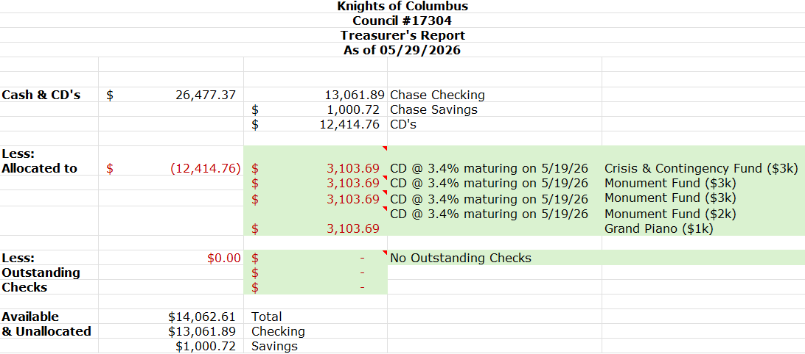

Membership Report – GK Nathan Bernard:
- Directors will turnover soon due to end of Fraternal Year.
- No additional activity to report now.

Faith in Action - Rob Daleo:

- Programs have been submitted online.
- June 18: Sacred Heart Holy Hour coming up
  - Need 4 Brothers to help with “parts”
- No other updates for remainer of year.

Fourth Degree Report – Ruben Diaz (incoming Faithful Navigator):
- 300 Flags set out and picked up a couple of weeks ago for Assembly Fundraiser.
- Installation of Officers was yesterday.
- Corpus Christi Procession was yesterday; Moved Inside Church

District Deputy Report -- Dominick Gervasi:
- State Deputy Ron Alonzo finishing term, new SD is Bob Goss.
- Chapter Meeting coming up in Arlington at the end of the month.
- District Conference in Houston at the end of the month. Dominick is not attending.
- Officer Installation is June 27 @ St. Catherine’s in Carrollton.
- July 1 begins next fraternal year.
  - SP7 Columbia Award Form is due soon.
  - Council is hitting all other marks.
- Our District is being re-organized and we are losing St. Catherine’s in Carrollton.
  - District will have only 3 Councils going forward.

Unfinished Business - None

New Business - George Siller:
- Bills to Pay:
  - $3.33 for Council transfer true-up
  - $125.38 - Bingo Dues to GK Nathan Bernard
    - $128.71 in total bills to pay
    - Motion by Ray and second by Ron Echevarria to pay bills; Motion carried by voice accolade.

- Council lost 18 members which we will transfer to online status due to non-payment.

- Motion to approve 2026-2027 budget:
  - Motion to adopt budget by Rob Daleo; Mark Murrin Second.
  - Budget passed via voice accolade.
Slate of 2026-2027 Officers was read:
- Grand Knight: Nathan Bernard
- Deputy Grand Knight: Mario Martinez
- Chancellor: Paul Parkes
- Treasurer: Sergio Guerrero
- Advocate: Brandon Story
- Recorder: Nick Cumberland
- Warden: Ron Echavarria
- Inside Guard: Marc Murrin
- Outside Guard: Michael Echavarria
- Trustee 1st Year: Rob Daleo
- Trustee 2nd Year: Steve Bredeson
- Trustee 3rd Year: Russ Woodford

2026-2027 Appointed Positions:
- Chaplain: Father Stephen Hauck
- Financial Secretary: George Siller (one more year)
- Lecturer: Jerry Barta

  - Motion to approve slate by Rob Daleo and second by George Siller.
    - Slate passed via voice accolade.

Good of the Order – GK Nathan Bernard:
June 2026 Knight of Month: Dominick Gervasi
June 2026 Family of the Month: Fremgen Family

Lecturer’s Reflection - Jerry Barta:
- Gospel of Matthew – Chapter 10 Verse 38
  - Everyone has suffering; accept it willingly.
  - Suffering works towards redemption.
  - Challenge: Pray Divine Mercy Chaplet everyday
    - Church has one at 7:20 each day.
    - Reflection: Do you carry your cross willingly, or is it forced on you?
      - Where do you turn with that weight?

Insurance Agent Report - Don Burks:
- Insurance Update, June 2026
- How much life insurance do you need?
  - How to pay final expenses
  - Emergency Funds

Grand Knight Summary - GK Nathan Bernard:
- Final meeting of Fraternal Year
- Look at SP7; we’ve done a lot this past year
- Plea: Get involved with programs that interest you.

Closing Prayer

Good of the Order:
- Rob Cronyn / Brother Mike Harris
- Rob Cronyn / Tony Byzwski - back surgery
- Don Burks / Mary Burks (mom) - stroke
- Rob Daleo / Recognize brothers who helped out during recent health issues:
  - Dominick (came to visit in hospital)
  - Ron Echavarria (built an ottoman for leg)
  - George Siller (came over with dinner several times.)

Prayer for the Canonization of Blessed Michael McGivney

GK adjourned meeting at 7:40 PM.
Minutes by: SK Brandon Story

Scan here for UKnight Quick Links:
  * requires login | 

