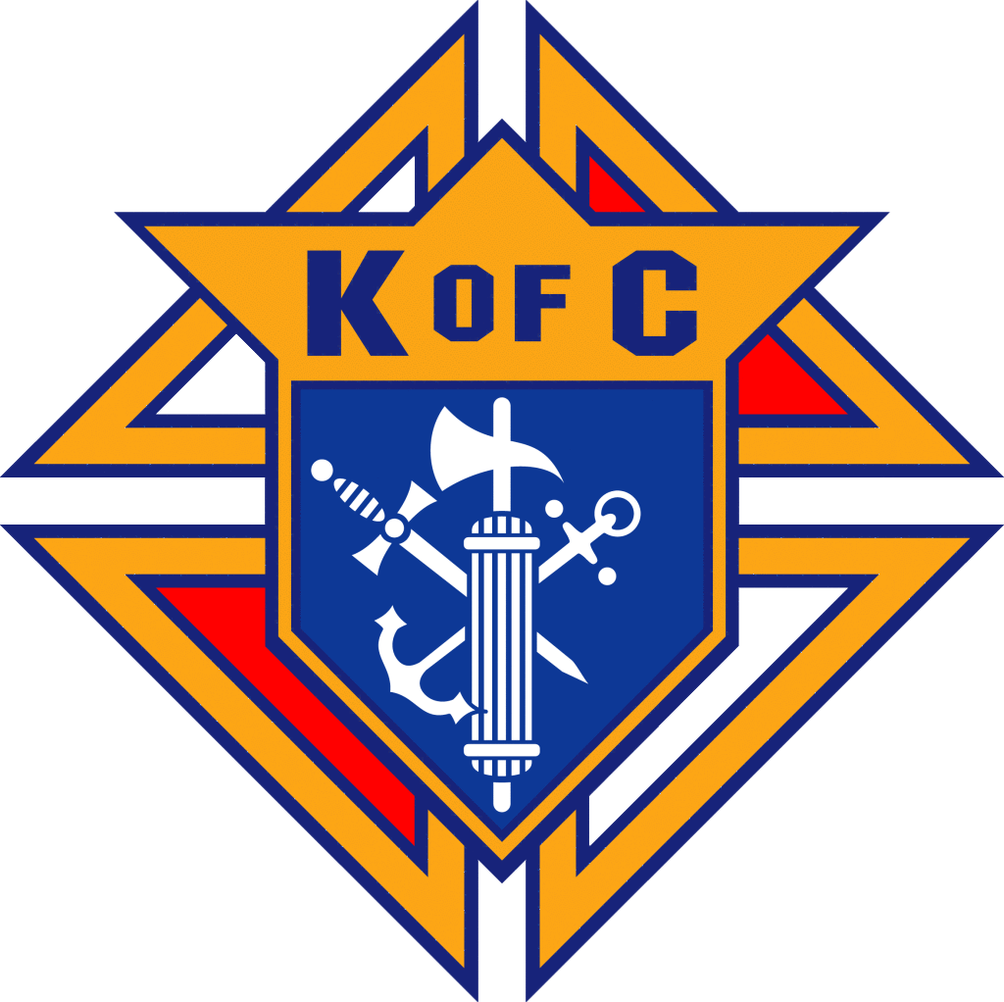
MONTHLY MEETING MINUTES
Knights of Columbus Council #17304
Date / Time: December 9, 2024
Location: St. Martin de Porres Church - Parish Hall

Meeting Details
Attendees: All officers present
Called to Order: 7:00 PM by Steven Bredesen, Grand Knight
Opening Items
- Prayer: Opening prayer led by Grand Knight.
- Pledge of Allegiance
Approval of Minutes
- Minutes of the previous meeting were posted online.
- Motion: Nathan motioned to approve; Paul seconded.
- Vote: Motion passed unanimously.

Officer Reports
Grand Knight’s Report – Steven Bredesen
- Upcoming Events:
  - December 12: Feast of Our Lady of Guadalupe – Mass at 8:00 AM and 6:30 PM.
  - December 14: Bingo Night – Volunteers needed for setup (4:30 PM) and teardown.
- Encouraged all members to recruit new candidates and participate in upcoming events.
Deputy Grand Knight’s Report – Nathan Bernard
- No new updates.
Treasurer’s Report – Sergio Guerrero
- Financial Summary (as of December 1, 2024):
  - Checking: $3,950.38
  - Savings: $12,396.30
  - Total: $16,346.68
- Outstanding Checks:
  - Norah Warren: $50.00
  - Nate Lee (Essay Contest): $50.00
  - Assembly 4001: $2,445.00
  - Ray Mangold: $246.29
  - Total Checks Outstanding: $2,791.29
- Allocations:
  - Crisis & Contingency Fund: $1,300.00
  - Monument Fund: $7,606.79
  - Grand Piano Fund: $900.00
  - Total Allocations: $9,806.79
- Available & Unallocated Funds: $3,748.60
Membership Report – Dean Hanson
- CUF Ceremony: Scheduled for January 18, 2025, at 11:00 AM.
- New Members Approved:
  - Noah Freeman (proposed and approved)
  - William “Biff” Pip (proposed and approved)
  - Ian Patrick (voted and approved after presentation by Matt Freeman and Dean Hanson)
  - Hector Castaneda (discussion deferred; vote postponed until next meeting).
- Mentorship program for new members will be initiated.
Faith Director Report – Richard Ornelas
- Feast of the Immaculate Conception: Observed on December 9 due to Sunday liturgical calendar adjustments.
- Feast of Our Lady of Guadalupe: Mass at 8:00 AM and 6:30 PM.
Family Director Report – John Ross
- John was absent; Nathan provided updates:
  - Christmas Coloring Mural Contest is underway. Volunteers encouraged to assist with setup.
Community Report – Alfredo (via Nathan)
- Bingo Night: Saturday, December 14. Setup begins at 4:30 PM, teardown around 9:00 PM.
- Essay Contest: Currently running, with results to be shared at the next meeting.
Life Program Report – Rob Daleo (in for Roland)
- Silver Rose Ceremony: Recently held; positive feedback received.
- Upcoming Events:
  - March for Life: Scheduled for January 18, 2025, in downtown Dallas.
  - Novena for Life: January 16–24, 2025.
  - White Cross Setup: Planned for the parish field along Highway 380.
St. Lawrence Team (Ray)
- Brisket Fundraiser:
  - Trial run planned for February 7–9, 2025.
  - Volunteers needed for cooking, prep, and distribution. Sign-up Genius to be sent out.
Technology Update – George/Nick
- No updates.
Fourth Degree Report – Rob Daleo
- Upcoming Events:
  - February 8: Next exemplification for the Fourth Degree at Prince of Peace in Plano.
  - December 14: Wreaths Across America Ceremony at 11:00 AM. Volunteers will assist with wreath distribution.
  - January 9: Blessed McGivney relic on display at St. Mary Magdalene Church, Winton, TX.
- Rob read the official decree for the formation of Reverend Lloyd Morris Assembly #4001.
Insurance Agent’s Report – Don Burks
- Presented on the importance of risk transfer and how Knights of Columbus insurance supports Catholic families.
Deputy Director Report – Dominic Gervase
- Recap of the Texas State Council meeting held in Dallas.
  - Emphasis on recruiting new members to maintain state leadership.
  - Council was awarded the Lone Star Council Award for excellence.

Unfinished Business
- None noted.

New Business
- Bills to Be Paid:
  - Dean Hansen’s CUF Expenses: $34.36 (motioned by Dean, seconded by Nathan; approved).
  - Sponsorship for Golf Tournament: $850 (motioned by Brandon, seconded by Nathan; approved).
- Safe Environment Training: Dean highlighted the importance of compliance; further discussion planned.
- Katie McCarthy Support Proposal: Mentioned as a potential future action item; Knights were encouraged to pray for her.

Good of the Order
- Prayer Requests:
  - Katie McCarthy: Stage IV cancer, prayers for recovery.
  - Dean Hansen: Upcoming CT scan.
  - Additional prayer requests were noted as listed in the rough draft.
Lector’s Reflection – Jerry
- Spoke about the Feast of Our Lady of Guadalupe and led members in a group prayer using provided prayer cards.

Grand Knight Summary
- Steven Bredesen thanked everyone for their contributions throughout the year and wished the council a Merry Christmas and Happy New Year.

Closing
- Closing Prayer: Led by Jerry.
- Adjournment: Meeting adjourned at 7:45 PM.

Older Prayer Items:
- Rob - Rob’s grandson is going through Covid and it has been tough - his parents as
- Pray for Bob (Jim’s brother), who is nearing end of life and afflicted with cancer.
- Sergio - pray for St. Sebastian church who is trying to start a new council
- George - pray for repose of the soul of his brother, Michael.
- Nathan - pray for Juanita (grandmother) - has covid in hospital
- Paul - Jim’s mother in law, who is in hospice now.
- Brother Austin Dunn - preparing for major surgery - prayers needed.
- Dominic - recovery from injury
- Edee Hanson - surgeries
- Parker Emerson - awaiting MRI results
- Lloyd Ruffle - in NY taking care of family - prayers for his Father
- Deacon Jack - nephew, Gilberto - broken neck - paralyzed from neck down and having trouble recovering.
- Prayer of Thanksgiving for Carlos’s son, - was in wreck over the weekend and he was able to walk awayCarlos Olivares: Repose of the Soul of Tino Soto
- Jim Slee: Bob Slee – Cancer
- George Siller: Deacon Jack / Mike Jacobsen
- Jesus Romero: Isella Romero – broken leg
- Ray Mangold / Prostate Cancer
- Rob Daleo: Chuck Daleo – Nursing Care
- Richard Ornelas: Brother Knights with Cancer
- GK Russ Woodford: Families of Shooting Deaths in Allen
- Stage 4 Cancer- Ray Wazwriack
- Father Boniface – Going through GI Issues
- Paul Parkes: Rob Daleo
- Richard Ornelaz: Tony Moninski, Hernia Surgery
- GK Russ Woodford: Carlos Olivarez FIL, Tino Soto removed from Life Support.
- Paul Parkes: Michael Jacobsen: Knee Replacement
- Paul Parkes: Deacon Jack Knee Replacement
- Sergio Guerrero: Gerald Hinderman, new kidney transplant
- Ed Flanagan: Twin grand-babies who are in the neonatal unit
- Richard Ornleas: John Curtin – car accident; Tony Byzewski who is going through hernia surgery
- Paul Parkes: Ed Flanagan, who was in car accident.
- Dominick Gervasi: Rob Daleo – health issues
- Richard Wilson who is getting a kidney transplant
- Sergio: Wife’s uncle Jared who is waiting for a Kidney Transplant
- Don Burk’s Dad – Shoulder surgery
- Prayers for Rob Daleo – blood pressure.
- Docs’ sister who has mammary cancer; Janice Jaymes
- Tony – hernia
- For all the people going on the Holy Land pilgrimage
- Dan Badgely – sister Julie passed away this morning.
- Ukrainian solders and country
- Fred Allen – passed away from Agent Orange related cancer; Ed Flanagan
- Terry Watting – Frank’s C fried with Pancreatic cancer
- Retired Deacon Richard Lovett; back surgery (George Siller)
- Pope Benedict
- Chuy Romero – possible Shoulder Surgery; appointment Friday.
- Tino Soto, Carlos’ Olivarez father in law in hospice
- Jason Campbell, cancer treatments
- Russ Woodford – in hospital
- Sister Andrea with Cancer
- Chuy Romero – dislocated shoulder.
- Tino Soto, Carlos’ Olivarez father in law in hospice
- Jason Campbell, cancer treatments in Germany at the end of the month.
- Repose of the soul of Ken Meline.
- In-laws: Tino and Olga Soto – Carlos Olivares
- Nephew, Max Obaye (surgery during birth); Nathan Bernard
- Prayers for Ken and Keith and new member Todd.
- Russ Woodford – prayers for healing.
- Appreciate everyone’s support.
- Ukraine – in 10 days, Knights raised $3M for relief efforts
- Republicans, Christians
- Supreme Court Justices
- Thom Vars - Christina Vars – turmoil at place of employment.
- Brandon Story: Cousin Robert Story who passed from Cancer recently.
- Cherie Brickey – return to good health
- Ukrainians – prayers
- Gary Hinderman – Waiting for Kidney Transplant
- Kathy Yasalli – heart condition and needs testing
- Edee Hansen – Diagnosed with syndrome which curls fingers
- Ed Flanagan: Grandson who is deployed on nuclear sub.
- Ruben Diaz: Peter Vargas – been ill
Minutes Prepared By: SK Nick Cumberland, Recorder

Scan here for UKnight Quick Links:
  * requires login | 