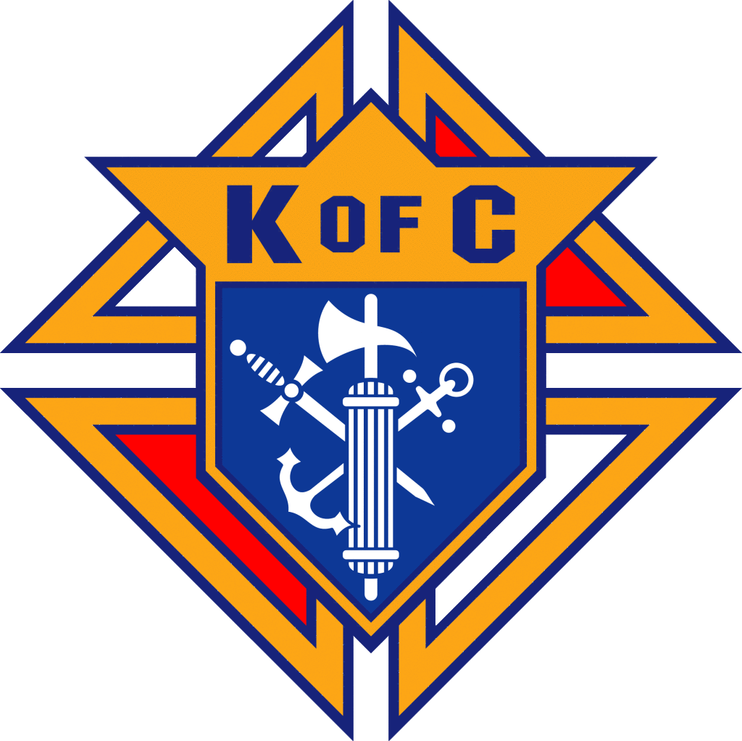
MONTHLY MEETING MINUTES
Knights of Columbus Council # 17304

Date / Time: September 9, 2024
Location: St. Martin de Porres Church - Parish Hall

Attendees:
Attendance was taken by Jean and an image of that sheet is included below.

Grand Knight Steven Bredesen called the meeting to order at 7:05 PM

Opening Prayer
Pledge of Allegiance

Approval of minutes for previous meeting:
- Minutes were posted online.
- Jerry Barta motioned to approve; Ed Flanagan seconded.
- Vote was taken and passed without any corrections.

Chaplain Update - Fr. Stephen
- New school year is underway; now have 400 students
  - New School wing construction is underway; Next August is completion
- Wednesday night is the main night for catechesis
  - New communal night on Wednesday with shared meal. One in October (Oct 9th) and 1x November
    - October 9 Communal Night will be a Parish Town Hall and Capital Campaign kickoff
  - Parish continues to grow; functions serve as an opportunity for Community Building
    - Ministry month continues this next weekend after mass.

Grand Knights Report – GK Steven Bredesen:
- Benefits webinar tomorrow – “Protect Those you Love”
- Rob is not here; keep him in your prayers
  - Food Pantry is having Golf Tournament in September.
    - They are asking for $850 for a sponsorship.
- Coats for Kids coming up in October.
- Essay Contest coming up; need to start planning.

Guests:
- Roger Girdwood
- Francis Oviesie

Deputy Grand Knight Report (Nathan):
- No report

Treasurer’s Report – George Siller

Membership Report – Dean Hansen
- Roger Girdwood – transfer from Houston
  - Motion made to accept by Ed Flanagan; no second; council voted to approve by voice accolade
- Francis Oviesie – 11:30 mass; two kids; married – New Member
  - Motion made to accept; council voted to approve by voice accolade
- CUF - September 21 at 11:00 AM – Overflow Room
- Doc is now in charge of the badges; see him for new badges.
- Wear work shirt or badges to masses; introduce yourself to new prospects.
- Sixteen guys lined up in Wichita Falls for CUF; get more members

Program Director – Nathan Bernard:
- 30 / 60 / 90 Tracker
  - October: Fall Festival

Family Director - John Ross:
- No Report

Faith Director - Richard Ornelaz:
- Communal Nights help – addressed above by Father.
  - Parish to pay for food; need help in the kitchen
- Buy tickets for the movie: “Heart of a Servant”
- See QR codes on notes to sign up for programs.
- Pray for our Bishops.
- We have fostered two Seminarians; sending them checks for support.
  - Remember them in your prayers
- Men’s Summit – June 27-28
- Asking to $50 for Rosary Ministry for Supplies
- Need people to show up for adoration, particularly from 10 PM – 4 AM.

Alfredo - Community
- Global Wheelchair Mission
- Annual Prosper Christmas Parade
- Coats for Kids coming up January / February
- Soccer Challenge – Fall Festival; going to reschedule to Spring
- Bingo: Two possible dates for next event - October 12 or December 7.
- Fall Festival Sign-ups; see QR code on planner

St. Lawrence Team (Ray)
- Last Taco Sunday was a huge success.
  - Team 2 was on deck; 8 people showed up
- Next Sunday for Taco Sunday – Team 1 is up.
- Fall Festival coming up; will need a brisket smoke before hand.
- November 8 – Taco Sunday Brisket Smoke

George / Nick- Technology update
- No Report

Life (Nathan and Paul Parkes in for Roland)
- Silver Rose – December 2
- Our Lady of Fatima – October 7; get together by flag post for rosary at 12 noon.
- Novena for Life - January

Fourth Degree Report –Rob Daleo:
- No Report; Rob is out sick.

Insurance Agent’s / Financial Advisor Report – Don Burks:
- Skilled Nursing Care; Tax Qualified Long Term Care

District Deputy Report – Dean Hansen for Dominic Gervasi:
- Need to keep meetings to one hour.
- Remember protocol; stand and motion to be recognized.

Unfinished Business
- None

New Business:
- Richard Ornelaz: Motion to donate $50 to Rosary & Adoration Committee for pamphlets – Motion by Richard and Second by Paul Parkes; Motion carried.

- BILLS TO BE PAID:
- Steve Bredesen: $238 for pizza dinner tonight
- Doc Hansen: $99.34 for new member kits
- Alfredo Aguirre: $33.95 and $34.05 for Bingo expenses

- Nathan Bernard moved to pay the bills - 2nd by Paul Parkes. Vote was taken and passed.

Grand Knight Summary – Steve Bredsen:
- George Siller: Fall Festival Update; Knights to cook brisket and serve meal
- Baskets for Silent Auction are needed by October 1; Bring to Parish Offices.
- Seven Sorrows of Mary this Month.

Trustee’s Report (Russ):
- No report this meeting

Good of the Order:
John Ross
- Family of the month – Miguel & Vanessa Hernandez
- Knight of the month - Rob Cronyn

Lector’s Reflection (Jerry Barta):
- Last month’s task was to recite a novena for Father McGivney.
  - Needs one more miracle to become a Saint.
  - Novena is on the Knights’ website.
- This month’s challenge: to make Peter’s profession of Faith each day – “You are the Messiah”.

New Prayer Items:
Brandon Story: Prayers for John Trevino, Father in Law, hospitalized with Kidney Stones.
Paul Parkes: Prayers for the repose of soul for Michael Siller.
Jim Slee: Prayers for the repose of Brother’s soul – Robert Slee.
Nathan Bernard: Prayers for third child on the way.

Older Prayer Items:
- Rob - Rob’s grandson is going through Covid and it has been tough - his parents as
- Pray for Bob (Jim’s brother), who is nearing end of life and afflicted with cancer.
- Sergio - pray for St. Sebastian church who is trying to start a new council
- George - pray for repose of the soul of his brother, Michael.
- Nathan - pray for Juanita (grandmother) - has covid in hospital
- Paul - Jim’s mother in law, who is in hospice now.
- Brother Austin Dunn - preparing for major surgery - prayers needed.
- Dominic - recovery from injury
- Edee Hanson - surgeries
- Parker Emerson - awaiting MRI results
- Lloyd Ruffle - in NY taking care of family - prayers for his Father
- Deacon Jack - nephew, Gilberto - broken neck - paralyzed from neck down and having trouble recovering.
- Prayer of Thanksgiving for Carlos’s son, - was in wreck over the weekend and he was able to walk away
- Carlos Olivares: Repose of the Soul of Tino Soto
- Jim Slee: Bob Slee – Cancer
- George Siller: Deacon Jack / Mike Jacobsen
- Jesus Romero: Isella Romero – broken leg
- Ray Mangold / Prostate Cancer
- Rob Daleo: Chuck Daleo – Nursing Care
- Richard Ornelas: Brother Knights with Cancer
- GK Russ Woodford: Families of Shooting Deaths in Allen
- Stage 4 Cancer- Ray Wazwriack
- Father Boniface – Going through GI Issues
- Paul Parkes: Rob Daleo
- Richard Ornelaz: Tony Moninski, Hernia Surgery
- GK Russ Woodford: Carlos Olivarez FIL, Tino Soto removed from Life Support.
- Paul Parkes: Michael Jacobsen: Knee Replacement
- Paul Parkes: Deacon Jack Knee Replacement
- Sergio Guerrero: Gerald Hinderman, new kidney transplant
- Ed Flanagan: Twin grand-babies who are in the neonatal unit
- Richard Ornleas: John Curtin – car accident; Tony Byzewski who is going through hernia surgery
- Paul Parkes: Ed Flanagan, who was in car accident.
- Dominick Gervasi: Rob Daleo – health issues
- Richard Wilson who is getting a kidney transplant
- Sergio: Wife’s uncle Jared who is waiting for a Kidney Transplant
- Don Burk’s Dad – Shoulder surgery
- Prayers for Rob Daleo – blood pressure.
- Docs’ sister who has mammary cancer; Janice Jaymes
- Tony – hernia
- For all the people going on the Holy Land pilgrimage
- Dan Badgely – sister Julie passed away this morning.
- Ukrainian solders and country
- Fred Allen – passed away from Agent Orange related cancer; Ed Flanagan
- Terry Watting – Frank’s C fried with Pancreatic cancer
- Retired Deacon Richard Lovett; back surgery (George Siller)
- Pope Benedict
- Chuy Romero – possible Shoulder Surgery; appointment Friday.
- Tino Soto, Carlos’ Olivarez father in law in hospice
- Jason Campbell, cancer treatments
- Russ Woodford – in hospital
- Sister Andrea with Cancer
- Chuy Romero – dislocated shoulder.
- Tino Soto, Carlos’ Olivarez father in law in hospice
- Jason Campbell, cancer treatments in Germany at the end of the month.
- Repose of the soul of Ken Meline.
- In-laws: Tino and Olga Soto – Carlos Olivares
- Nephew, Max Obaye (surgery during birth); Nathan Bernard
- Prayers for Ken and Keith and new member Todd.
- Russ Woodford – prayers for healing.
- Appreciate everyone’s support.
- Ukraine – in 10 days, Knights raised $3M for relief efforts
- Republicans, Christians
- Supreme Court Justices
- Thom Vars - Christina Vars – turmoil at place of employment.
- Brandon Story: Cousin Robert Story who passed from Cancer recently.
- Cherie Brickey – return to good health
- Ukrainians – prayers
- Gary Hinderman – Waiting for Kidney Transplant
- Kathy Yasalli – heart condition and needs testing
- Edee Hansen – Diagnosed with syndrome which curls fingers
- Ed Flanagan: Grandson who is deployed on nuclear sub.
- Ruben Diaz: Peter Vargas – been ill

Closing prayer

Meeting was adjourned by Steve at 8:34 PM.
Minutes by: SK Brandon Story

Scan here for UKnight Quick Links:
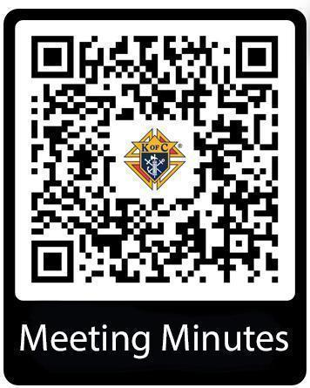  * requires login | 

